**I/O and arrays**

0. Write a program that uses **printf()** with all these format specifiers: %c, %d, %i, %lld, %u, %llu, %f, %lf.

1. Write a program that reads in an **integer**, converts it into a **long long integer**, and then prints it on 10 positions. Test with 42.

Hint: Use ***typecasting*** to convert.

2. Which of the following correctly declares an array? (circle)

**A. int foo[10];**  B. int foo; C. foo{10}; D. array foo[10];

E. float foo(20) = {1.5, 2.5}; F. double foo[] = {3.5, 4.5, 5.5}

3. What is the index number of the last element of an array with 29 elements?

A. 29 **B. 28**  C.30 D. 0 E. Programmer-defined

4. Which of the following correctly declares a two-dimensional array?

A. array bar[20][20]; B. array bar[20, 20]; **C. int bar[20][20];**

D. int bar[20, 20]; E. char bar[20]; F. float bar[2][3] = {-1.5};

5. Which of the following correctly accesses the seventh element stored in **foo**, an array with 100 elements?

**A. foo[6];** B. foo[7]; C. foo(7); D. foo; E.foo[0] F.foo{0}

6. Write a program that declares an array of 30 elements and then places in it the cubes of the numbers from 1 to 30. Print the array on one line.

7. Write a program that creates an array of 100 elements, and stores in them the first 100 even numbers. Print the first 10 elements on one line, and the last 10 on another.

8. What happens if in a C program we assign a value to an array element whose subscript exceeds the size of the array?

A. The element is set to 0. B. The element is set to -1. C. The compiler reports an error.

**C. The program may crash if some important data gets overwritten.**

D. The array size grows automatically. E. The universe suddenly disappears.

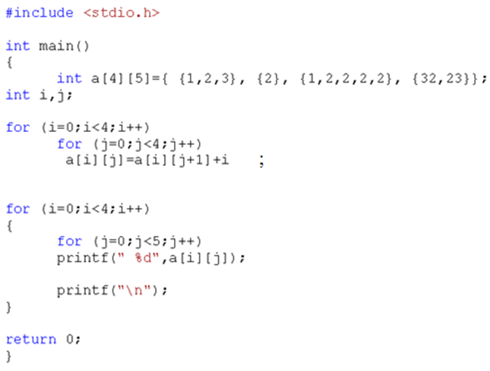9. Simulate the execution of this program with pencil and paper, and write down:

The matrix after The matrix after

initialization: the for loop:

1 2 3 0 0 2 3 0 0 0

2 0 0 0 0 1 1 1 1 0

1 2 2 2 2 4 4 4 4 2

32 23 0 0 0 26 3 3 3 0

Write on paper a similar nested loop to print the matrix on the screen.

for(int i = 0; i < 4; i++)

{

for(int j = 0; j < 5; j++)

printf("%d\t", arr[i][j]);

printf("\n");

}

printf("\n");

**Problems for lab report:**

Note: For all problems marked with ►, take screenshots of both code and output, paste the screenshots in a report file, and submit it to Canvas as a .pdf file.

10] ► Write a program that reads in a **double**, converts it into a **long long integer**, and then prints it on 8 positions. Test with 4243.44.

11] ► Write a program that declares an array of 50 elements and then places in it the square roots of the numbers from 1 to 50. Print the array on one line. Select the proper types.

Hint: You need to include math.h.

12] ► Write a program that creates an array of 50 integers, and stores in them the first 50 terms of this sequence: 1, 4, 7, 10, … Print the array on one line.

Hint: Find a general formula for the sequence!

